NOTE: PLEASE DO NOT WRITE IN THIS BOX!

………………………………………………………………………. ……….... …………
name technical № entry №

Examining Committee:

- ………………………………………………………………

- ………………………………………………………………

Final mark: …………………………………………………………

Entry test in …………………………………
Date .…………………………………………

ENTRY TEST CHEMISTRY
2019/2020 Academic year
AT MEDICAL FACULTY, TRAKIA UNIVERSITY, STARA ZAGORA

Mark the correct answer:
1. Which element on the periodic table has physical properties most similar to the physical properties of chlorine?
- Sodium
- Oxygen
- Carbon
- Florine

2. Which of the following is true regarding the concentration of products, for a chemical reaction that is already at equilibrium, assuming no disruptions to the equilibrium?
- The concentrations of products will not change because there are no more reactants.
- The concentrations of products will not change because the limiting reagent is gone.
- The concentrations of products will not change because the forward and reverse rates are equal.
- The concentrations of products will change continually because of reversibility.

- Hydrogen bonding would be seen in a sample of which of the following substances
- CH₄
- H₂
- H₂O
- None of the above

- Select the ionic compound
- CO₂
- P₂O₅
- N₂O₃
- MgO

- What is the chemical character of K₂O?
- Acidic
- Basic
- Amphoteric
- Metallic

- Which of the series below contains only acids?
- NaOH, Ca(OH)₂, LiOH
- NaOH, K, CaO
- NaOH, SO₂, S
- HCl, H₂CO₃, H₂SO₄

- Which of the series below contains only bases
- NaOH, KOH, LiOH
- NaOH, K, Ca
- NaOH, KOH, S
- KOH, LiOH, H₂SO₄

- What are the products of reaction Na + HCl →?
- Salt and hydrogen
- Hydride and base
- Basic and acidic oxides
- Acid and base

- What are the products of reaction Zn + CuSO₄?
- Zinc sulfate and copper
- Zinc oxide and copper oxide
- Zinc oxide, copper oxide and sulfur dioxide
- Zinc oxide, copper oxide and oxygen

- What is the product of reaction K + Cl₂?
- Base
- Salt
- Covalent compound
- Acid

- Which statement is correct?
- Oxidation is loss of electrons and reduction is gain of electrons
- Oxidation is gain of electrons and reduction is loss of electrons
- Oxidation is loss of protons and reduction is gain of electrons
- Oxidation is loss of electrons and reduction is gain of protons

- Which statement is correct?
- The oxidizing agent is normally in one of its higher possible oxidation states because it will gain electrons and be reduced
- The oxidizing agent is normally in one of its higher possible oxidation states because it will losses electrons and be reduced
- The oxidizing agent is normally in one of its lower possible oxidation states because it will losses electrons and be reduced
- The oxidizing agent is normally in one of its lower possible oxidation states because it will losses electrons and be oxidized

- Oxidation of aldehydes with Tollens' reagent
- Select the name of the given compound
CH₃
|
CH₃ ̶ CH₂ ̶ CH ̶ C ̶ Cl
| |
Br CH₃
- 1-bromo-2-chloroisobutane
- 3-bromo-4-chloro-4,4-dimethylbutane
- 2-bromo-1-chloro-1,1-dimethylbutane
- 3-bromo-2-chloro-2-methylpentane

- The correct systematic name of the hydrocarbon with the condensed structural formula is:
CH₃ CH₃
| |
CH₃ ̶ C ̶ CH₂ ̶ CH
| |
CH₃ CH₃
- 1,1,3,3-tetramethylbutane
- 2,2,4-trimethylpentane
- 2,2,4,4-tetramethylbutane
- Isooctane

- The substance with formula C₆H₁₂ is called
- Hexane
- Hexene
- Hexol
- Hexenoic acid

- Compounds with the – OH group attached to a saturated alkane – like carbon are known as
- Alkohols
- Phenols
- Alkyl halides
- Hydroxyls

- Express the esterification reaction:
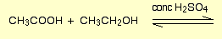

- Ethanal is prepared by oxidation of
- Ethanol
- Acetaldehyde
- Propan-1-ol
- Propan-2-ol

- The systematic name for acetone is
- Propanone
- Propanal
- Propanoic acid
- Ethandiol

- Write the structures of the following compounds:
  - Formaldehyde
  - Acetone
  - Acetic acid

- What is the major product of the following reaction?
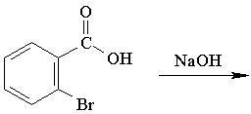
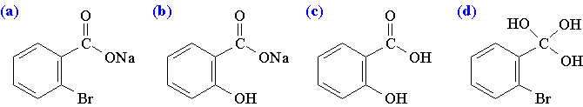

23. Which of the following reaction sequences would be the best synthesis of 2-pentanone. Continue all reactions
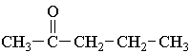
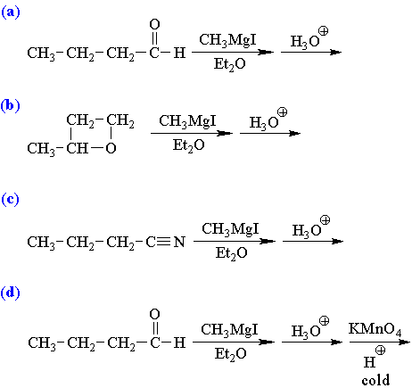
24. The peptide bond is formed by reaction between:
- Two carboxylic groups
- Hydroxylic group and carboxylic group
- Amino group and carboxylic group
- No answer is correct

- What type of covalent bonds link the amino acids in a protein?
- Peptide bonds
- Hydrogen bonds
- Glycosidic bonds
- Ester bonds

26. Which of the following is a methylene group?
- A CH₄ group
- A CH₃ group
- A CH₂ group
- A CH group

- Give the correct common name of the standard amino acid whose structural formula is:
CH₃
|
NH₂ ̶ CH ̶ COOH
- Glycine
- Alanine
- Leucine
- Serine

- Carbohydrates may contain the functional groups:
- Of an aldehyde
- Of a ketone
- Hydroxyl groups
- All of the above

- Which of the following substance is a hexose?
- Fructose
- Arabinose
- Ribose
- None of the above

- Which two mono saccharides will be formed by hydrolytic cleavage of sucrose?
- Glucose and fructose
- Two molecules of glucose
- Glucose and galactose
- Two molecules of fructose

